Effect of water, sanitation and hygiene interventions on enteropathogen detection in the environment: an individual participant data meta-analysis

Andrew Mertens, Jack Colford, Oliver Cumming, Joe Brown, Jill Stewart, David Holcomb, Jackie Knee, Tom Clasen, Heather Reese, Amy Pickering, Clair Null, Steve Luby, Jessica Grembi, Ben Arnold, Audrie Lin, Jade Benjamin-Chung, Laura Kwong, Lauren Steinbaum, Ali Boehm, Kara Nelson, Erica Fuhrmeister, Mahbubur Rahman, Sammy Njenga, Rassul Nala, Ruwan Thilakaratne,Ayse Ercumen (middle order not finalized)

## Abstract

**Background:** Drinking water, sanitation, and hygiene (WASH) improvements are considered cornerstones to reduce diarrheal disease in low-income countries. However, recent randomized controlled trials have found no or mixed effects of household- and community-level WASH interventions on child health. Assessing fecal pathogens in the environment as an intermediate variable can illuminate whether the limited health effects of WASH interventions occur because they do not cause a cleaner environment. **Methods:** We conducted a systematic review and individual participant data meta-analysis to assess the effects of WASH interventions on enteric pathogens and microbial source tracking (MST) markers in environmental samples. We estimated intervention effects on the prevalence of any pathogen and any MST marker, and the prevalence and abundance of specific pathogens and MST markers. We used covariate-adjusted regression models with robust standard errors. **Findings:** We identified and received data from five randomized or quasi-experimental studies (four focused on sanitation in the environmental sampling, one on piped water and sanitation). Most individual studies found no intervention effects on pathogens or MST markers in environmental samples, including drinking water, hands, soil and flies. We found a small but significant reduction in the prevalence of any pathogen in any sample type, with a pooled, adjusted prevalence ratio of 0.94 (95% CI: 0.89, 0.99). There was no overall effect on MST markers, and no consistent differences in intervention effects by season or animal presence, and between urban/rural settings or randomized/quasi-experimental study designs. **Interpretation:** The small effect of sanitation interventions on pathogens in the environment is consistent with the lack of health impact in sanitation trials. **Funding:** The Bill and Melinda Gates Foundation

## Research in context

**Evidence before this study.**

Children in areas with poor drinking water, sanitation, and hygiene conditions (WASH) have increased diarrheal disease and reduced growth. Previous intervention studies on WASH improvements have generally not had large effects on reducing diarrheal disease in children or improving child growth by reducing enteric infections. Quantifying the effect WASH improvements have on reducing enteric pathogens in environmental samples may help elucidate if interventions are helping block the causal path between poor WASH, environmental fecal contamination, and poor child health. We conducted an individual participant data meta-analysis of WASH intervention studies that measured pathogens or microbial source tracking (MST) markers in the environment to see if interventions reduced different types of pathogens in soil, drinking water, hand rinse, and fly samples.

**Added value of this study.**

We were able to collect data from most trials sampling environmental pathogens that we identified in a systemic review of the literature. Most relative risks indicated a protective effect of interventions for individual pathogens and MST marker prevalences, but sample sizes were small within individual studies and most estimates were not statistically significant. However, the individual participant data meta-analysis design of the study allowed us to detect a small but significant reduction in any type of pathogen presence in any type of sample when pooled across trial intervention arms, though there was not a effect of interventions on the presence of any type of MST marker

**Implications of all the available science.**

Though there was an overall effect of WASH interventions on pathogen presence, it was small, which may underly the small effect interventions have had on child health. Possibly, more intensive WASH interventions like piped and safely managed water and sanitation are needed to reduce environmental contamination enough to improve child health. However, there were only 6 trials meeting our inclusion criteria, and of the 5 we received data from, 4 of 5 only included a sanitation intervention or sampled the sanitation arm. Pathogen-specific detection methods are relatively expensive, so only a subset of households were sampled in each study, and pathogen targets varied greatly by study, complicating interpretation of a results. Future research would benefit from sampling a more diverse set of WASH interventions using a standardized set of laboratory methods and pathogen and MST targets.

## Introduction

Water, sanitation and hygiene (WASH) improvements are often assumed to reduce childhood enteric infections, subsequent diarrhea disease and growth faltering by reducing child exposure to fecal-orally transmitted pathogens in the environment. Until recently, trials of WASH interventions have primarily focused on documenting health outcomes such as caregiver-reported diarrhea without quantifying intermediate outcomes along the causal chain, such as detection of pathogens in environmental samples and in human biological specimens. Without measuring these causal intermediates, trials are limited to a “black box” understanding, where underlying mechanisms of interventions are unknown and investigators can only speculate about reasons for intervention success or failure. Inspecting the causal chain is especially important given the small or null effects on child diarrhea and growth reported in recent well-conducted trials of WASH interventions.1–3

Pathogens are transmitted from the feces of infected individuals to new hosts through interconnected environmental pathways. Studies assessing the effect of WASH interventions on environmental contamination have to date primarily focused on drinking water (and, to a smaller extent, hands and food) while other pathways such as soil and surfaces in the domestic environment have received less attention.4 Household water treatment and handwashing have been associated with reduced fecal contamination of drinking water5 and hands,6,7 respectively while sanitation interventions have had limited impact on environmental fecal contamination, including drinking water, hands, objects, surfaces, soil and flies.4

These studies have mostly relied on measuring indicator organisms such as *E. coli* in the environment as a proxy for pathogens; these indicators can originate from non-fecal sources,8 cannot differentiate between human vs. animal fecal sources,9 and correlate poorly with pathogens and disease risk.10 Recent advances in DNA-based diagnostics now allow detection of a range of enteropathogens in human biological specimens and environmental samples,11,12 as well as distinction between human vs. animal fecal sources through molecular source tracking (MST).13 We aimed to assess the effect of WASH interventions on detection of specific enteropathogens and human- vs. animal-specific MST markers in the domestic environment with a systematic review and an individual participant data (IPD) meta-analysis. Through the IPD approach, we collected environmental sample-level data as well as household covariates to allow us to standardize the analytic approach, outcome definitions, and subgroup analyses.

## Methods

### Search methods

We conducted a systematic literature search to identify WASH intervention studies that have measured pathogens and/or MST markers in environmental samples as well as at least one of the following health outcomes in children: caregiver-reported diarrhea, growth or pathogen detection in stool. We focused on studies with environmental as well as child health measurements in order to assess (1) the impact of WASH interventions on environmental contamination, (2) associations between measures of environmental contamination and child health outcomes, and (3) examine the hypothesized causal pathway from WASH intervention to child health mediated through reduced environmental contamination. In this paper, we present findings for the first aim. The analyses for the latter two aims are presented in a companion paper (Mertens 2021).

We developed a search strategy with a two-step process. First, we examined known studies meeting our inclusion criteria for keywords and Medical Subject Heading (MeSH) terms relating to WASH interventions, microbial source tracking, environmental contamination, enteric infection; diarrhea, and child growth. Next, we performed an initial search using these terms and extracted other relevant terms and synonyms from the search results. Search terms are listed in Supplementary Table S1. We searched the PubMed, Embase, CAB Direct Global Health, Agricultural & Environmental Science Database, Web Of Science, and Scopus databases. Our PubMed search string is listed in Supplementary Table S2. We only included studies published after 2000 so that only more recently developed advanced pathogen detection methods were included. We limited our search to studies published in English. We included studies meeting the following inclusion criteria: 1) prospective studies with a water, sanitation, or hygiene intervention and concurrent control (i.e., randomized controlled trial, matched cohort, controlled before-and-after study), consistent with prior WHO burden of disease reviews , [@wolfImpactDrinkingWater2018; @wolfSystematicReviewAssessing2014] 2) measured pathogens and/or MST markers in environmental samples, and 3) measured child anthropometry, diarrheal disease, or pathogen-specific infections for use in a companion manuscript [Mertens et al. 2021]. We excluded studies that only measured fecal indicator bacteria (FIB) such as coliforms or *E. coli*, which are commonly used as measures of fecal contamination but are not specific to fecal sources and cannot distinguish the source of contamination.14 One/reviewer (AM,) screened the abstracts of studies according to our inclusion/exclusion criteria, and two independent reviewers (AM, RT) examined the full texts of relevant short-listed articles.

Data Collection and Analysis For each published study eligible for inclusion in the IPD meta-analysis, we contacted the corresponding authors to request individual data on the presence and abundance of pathogen and MST markers in environmental samples, child health outcomes, and potentially confounding baseline characteristics, including socioeconomic and demographic indicators. All personal identifiers were removed from the data, including GPS locations, and sampling dates were coarsened to a monthly resolution. If the corresponding author was unwilling to share individual data, that study was excluded from our analysis.

Our primary outcomes were the detection of any enteropathogen and of any MST markers in any type of environmental sample. We analyzed prevalences separately for each sample type (e.g., water, hands, soil, flies) and also as a composite prevalence measure indicating presence of a given target in any sample type collected from the same compound during the same sampling round. Secondary outcomes included the prevalence of specific pathogen types (any viruses, any bacteria, any protozoa, any helminths), the prevalence of MST markers from specific host types (general, human, animal), and the prevalence and abundance of individual enteropathogens and MST markers.

We compared each outcome between the WASH intervention and control arms of the included studies. For prevalence outcomes, we estimated prevalence ratios using modified Poisson regressions.15 For abundance outcomes, we used linear regressions to estimate differences in log-transformed gene copies obtained from molecular methods, and we used negative binomial regressions to estimate count differences in soil-transmitted helminth (STH) egg counts obtained from microscopic methods. Because of repeated sampling or clustered designs in some studies, we used the Huber Sandwich Estimator to calculate robust standard errors for all estimates.16 We used the compound (group of households with shared sanitation) as the independent unit in non-cluster-randomized studies and the specified unit of clustering in cluster-randomized trials. For the pathogen or MST abundance measures, we imputed values for samples below the limit of quantification (LOQ) and the limit of detection (LOD). We used the original study’s imputation strategy if available and otherwise imputed values ourselves. For samples below the LOD, we used half the LOD and for samples below the LOQ, we used the midpoint between the LOD and LOQ for the imputation. To avoid analyzing targets where most of the data were imputed, we only included targets where at least 50% of samples were within the quantifiable range in our analysis.

All analyses were adjusted for potential confounders. While estimated effects of WASH interventions from randomized controlled trials should be unconfounded, covariate adjustment may increase statistical efficiency, and improve exchangeability in comparing and combining estimates with matched cohorts and non-randomized trials.17 Potential confounders were prescreened using likelihood ratio tests, and only variables associated with the outcome with a p-value < 0.2 were included in the model for each outcome. We included the following variables in the prescreening set if they were measured within an included study: number of people in the household, age and education of primary caregiver in the household, asset-based household wealth, number of rooms, household construction materials (walls, floor, roof), access to electricity, land ownership and if anyone in the household works in agriculture. For rare binary outcomes, we only included one independent variable in the model (including the treatment arm and any potential confounders) per 10 positive samples, or per 10 negative samples if <50% of samples were negative. We therefore did not estimate prevalence ratios for any targets with fewer than 10 positive or negative values for a given sample type, or with fewer than two positive or negative values per study arm for a given sample type. Targets with <10 negatives were also excluded from the composite “any pathogen” and “any MST marker” variables to avoid generating sparse cells; targets with <10 positives were included in the composite variables.

Due to study-specific differences in local WASH conditions, open defecation rates, climate, ruralness, and infectious disease patterns, we reported individual study-specific estimates for all analyses. For targets where data were available from four or more studies, we tested for heterogeneity in estimates using Cochran’s Q-test.18 If there was no significant heterogeneity between individual study estimates (p-value>0.2), we pooled estimates using fixed-effects models. If there was evidence for heterogeneity but there was qualitative support for combining studies, we pooled estimates using random-effects models.

We conducted subgroup analyses by season (dry/wet), animal ownership (at least one animal owned/no animal owned) and pathogens with zoonotic vs. no zoonotic transmission. The wet season for each study was defined as the 6 months of highest average rainfall, obtained from <https://www.weather-atlas.com/>.19 The pathogens we considered zoonotic were *Campylobacter, Salmonella, Yersinia enterocolitica, C. difficile, Cryptosporidium, Giardia* and *Ascaris*.20 Studies included detected virulence genes associated with specific *E. coli* pathotypes (EAEC, EPEC/EHEC, STEC, EIEC, ETEC). Among these, we classified STEC and EPEC (due to atypical EPEC) as zoonotic.20. We calculated prevalence ratios for any pathogens and any MST markers between intervention and control groups within these subgroups. We assessed effect modification by examining the p-values on the interaction terms between the treatment and the indicator variable for the subgroup in the regression models; a p-value <0.2 was considered evidence of effect modification. There was no heterogeneity in study setting within any individual study as each study was conducted either in a primarily rural or primarily urban setting. We therefore explored heterogeneity by study setting by pooling estimates separately for rural vs. urban studies and comparing the pooled estimates with Wald tests. We used the same approach to explore heterogeneity by study design by separately pooling estimates from randomized and quasi-experimental studies.

All analyses were conducted in R 4.0, and analysis scripts are publicly available (<https://github.com/amertens/wash-ipd>). The systematic review search strategies and the analysis plan were pre-registered on Open Science Framework (<https://osf.io/8sgzn/>). Our PRISMA checklist can be found in Supplementary Table S3.

## Results

### Search results

The systematic review was conducted on 1/19/2021 and returned 3,376 results after removing duplicates. Of these, 3,253 were excluded by abstract screening, and of the 125 short-listed studies, eight met the inclusion criteria after full-text screening. The eight included studies reported findings from six unique intervention studies: the WASH Benefits Bangladesh and Kenya trials,21 the MapSan (Maputo Sanitation) controlled before-and-after study in Mozambique,22 the Gram Vikas matched cohort study in India,23 the Odisha Total Sanitation Campaign trial in India,24 and the CHoBI7 trial in Bangladesh25 (Table 1). Data were obtained from all studies except the CHoBI7 trial where the investigators declined to share data. For the Odisha Total Sanitation Campaign trial, only village-level source water quality data were shared.

### Characteristics of included studies

The WASH Benefits trials were cluster-randomized, multi-armed factorial designed trials of water, hygiene, sanitation, and nutrition interventions in rural Kenya and Bangladesh, but pathogens and MST markers in environmental samples were only measured in the control and sanitation arms. The sanitation intervention included the construction of a double-pit pour flush improved latrine latrine and the provision of a child potty and sani-scoop for feces removal. The MapSan study was a controlled before-and-after study of a decentralized sanitation intervention in urban Mozambique. The intervention entailed the construction of flush toilets that drain to septic tanks, shared by a minimum of 15 people. The intervention delivery was not randomized, but control sites were matched to intervention sites based on both size of the compound and time of enrollment. The Gram Vikas study was a matched cohort evaluating the effect of a piped water and sanitation intervention provided by the Gram Vikas non-governmental organization in rural India. Gram Vikas built a water tank and piped distribution system, and provided materials for the construction of pour-flush toilets in each household. After each household in the village completed latrine construction, the water system was turned on for the whole village. The control villages were matched to intervention villages on pre-intervention characteristics. The Total Sanitation Campaign study in Odisha, India, was a cluster-randomized trial assessing the Government of India’s Total Sanitation Campaign, which included promoting the construction of a pour-flush latrine with a single pit and Y-joint for a future second pit which was subsidized post hoc at a household level by government funding.

### Sample types and target detections in included studies

Seven unique studies on pathogen or MST presence in the environment were nested within the five randomized and quasi-randomized interventions with available data. Three separate publications reported pathogen and MST detection results from the WASH Benefits Bangladesh study . [@boehmOccurrenceHostAssociatedFecal2016; @fuhrmeisterEffectSanitationImprovements2020; @kwongEffectSanitationImprovements2020] These publications focused on samples collected from different subsets of trial participants at different times; therefore, we report results from these three studies separately . We received unpublished data on fly pathogens detected on flies caught in the household from the MapSan study, which we include within the Holcomb 2020 study in the reported results. For the Odisha Total Sanitation Campaign trial, only village-level source water quality data were shared.

The types of samples collected included source and stored drinking water, child and mother hands, soil from the courtyard, household and latrine areas, food, and flies caught in the compound’s latrine and kitchen areas. The number of individual environmental samples in included studies varied from 6031 to 345228. The pooled dataset across all studies included 12,199 individual samples, with a total of 41,692 observations for pathogen/MST marker prevalence. Samples were collected from 3-6 months to 6-10 years after intervention delivery, with most studies collecting samples 1-2 years later (Table 1).

Across the seven studies, three only measured pathogens and no MST markers (Table 1); two WASH Benefits trial studies measured *Ascaris lumbricoides* and *Trichuris trichiura* eggs in soil,26,27 and Reese et al. 2017 measured *V. cholerae* and *Shigella* in source and stored drinking water samples.28 Boehm et al. 2016 measured rotavirus as well as general, human, and ruminant and avian fecal markers.29 Fuhrmeister et al. 2020 measured pathogenic *E. coli*, *Giardia*, norovirus, and human and animal fecal markers,30 while Odagiri et al. 2016 measured *V. cholerae*, rotavirus, adenovirus, and general, human, and animal fecal markers.31 Holcomb et al. 2020 measured the largest number of targets, including pathogenic *E. coli, V. cholerae, Shigella, Campylobacter, Salmonella, Yersinia, C. difficile, Cryptosporidium, Giardia, Entamoeba histolytica*, rotavirus, norovirus, sapovirus, adenovirus, astrovirus, pan-enterovirus, STH, and general, human, and animal fecal markers (Tables S4-S7).32

Many targets had very low or no variation in prevalence for a given sample type, with 26/275 target-sample combinations having no variation in prevalence (all samples negative), and 62/275 of combinations having too little variation to estimate a prevalence ratio (<10 positive or negative samples). Among these sparse target-sample combinations, most (88.7%) had too few positive samples, and 11.3% had too few negative samples. Specifically, the BacCow animal fecal marker in Odagiri et al. 2016, the GenBac3 general fecal marker in Boehm et al. 2016, and the human Bacteroides marker in Holcomb et al. 2020 had close to 100% prevalence. Upon inspection of the data, we excluded these three targets from the aggregated “any MST marker” variable to allow estimation of prevalence ratios. Holcomb et al. 2020 measured human (Bacteroides and M. smithii) and avian (GFD) MST targets in 183 food samples , but there were no samples positive for GFD, 2 samples positive for M. smithii, and 7 samples positive for Bacteroides so we did not estimate prevalence ratios for MST markers in food samples for this study nor include these markers in the aggregate variables. Overall, 187/275 sample-target combinations had sufficient variability to be individually included in our meta-analysis. Among these, the prevalence of pathogens ranged from 2.3% (Giardia on mothers’ hands in Fuhrmeister et al. 2020) to 61.7% (*Ascaris* in soil in Kwong et al. 2021), and the prevalence of MST markers ranged from 2.4% (HumM2 on child hands in Boehm et al. 2016) to 96.7% (BacCow on mothers’ hands in Fuhrmeister et al. 2020).

### Intervention effects on the prevalence of any enteropathogen and any MST marker

The interventions generally decreased the prevalence of pathogens and MST markers but the prevalence ratios often crossed the null, with 73.3% (137/187) of study-specific estimates of intervention effects being protective but non-significant and 6.4% (12/187) being protective and significant. Interventions decreased the prevalence of any pathogen in any sample type in all specific studies except for Boehm et al. 2016 but the decrease was only significant in Fuhrmeister et al. 2020 with an adjusted PR of 0.92 (95% CI: 0.86, 0.98). The interventions had no significant effects on the prevalence of any pathogen among individual sample types (Figure 1). Overall, study-specific estimates were largely homogeneous, with no significant Cochran’s Q-tests of homogeneity. Therefore, we pooled estimates using fixed-effects models. When pooled across all studies, there was a small reduction in the prevalence of any pathogen detected in any sample type, with an adjusted pooled PR of 0.94 (95% CI: 0.89, 0.99) (Figure 1). Interventions had no effect on the prevalence of any MST marker in any sample type (adjusted pooled PR= 0.99 (95% CI: 0.95, 1.04)) or within specific sample types.

### Intervention effects on the prevalence of pathogen types and individual pathogens

When examining prevalences of types of pathogens, interventions reduced the prevalence of any bacterial pathogens in any sample type, with 11 out of 13 study and sample-specific prevalence ratios indicating a protective effect of interventions (Figure 2), though the effect was only significant in any sample type in Fuhrmeister et al. 2020, with an adjusted PR of 0.92 (95% CI: 0.86, 0.99). Pooled across all studies, interventions reduced the prevalence of any bacteria in any sample type, with an adjusted pooled PR of 0.91 (95% CI: 0.85, 0.97). Interventions only reduced STH in soil in Holcomb et al. 2020 (adjusted PR: 0.60 (95% CI: 0.42, 0.85)) and in any sample type (adjusted PR: 0.64 (95% CI: 0.45, 0.93), Figure 2). Interventions did not significantly reduce the presence of viruses or protozoa in any sample type or within specific types of samples, though point estimates from individual studies were protective for all combinations except for viruses on child and mother’s hands (Figure 2). Among specific pathogens, interventions reduced the prevalence of pathogenic *E. coli* in any sample type in Fuhrmeister et al. 2020 (adjusted PR: 0.92 (95% CI: 0.86, 0.99)) and of adenovirus (adjusted PR: 0.20 (95% CI: 0.06, 0.63)), and *Shigella* (adjusted PR: 0.32 (95% CI: 0.11, 0.93)) in Holcomb et al. 2020 (Figure S1). These reductions were driven by significant reductions in soil samples in Holcomb et al. 2020 and by non-significant reductions in all sample types in Fuhrmeister et al. 2020.

### Intervention effects on the prevalence of MST marker types and individual markers

Among specific types of MST markers (general, human, animal), effects of interventions were inconsistent and largely null, with 30 out of 54 study-specific prevalence ratios indicating a protective effect of interventions (Figure 3). The only significant estimates were observed for any animal MST marker in stored water in Boehm et al. 2016 (adjusted PR=0.67 (95% CI: 0.49, 0.93)), driven primarily by a significant effect of the sanitation intervention on the ruminant (BacR) marker (adjusted PR: 0.60 (95% CI: 0.41, 0.88), Figure S2). There were no other intervention effects on individual MST markers (Figure S2).

### Intervention effects on the abundance of individual pathogens and MST markers

Of all the samples collected, 21.8% had abundances quantified, including STH egg counts in Steinbaum et al. 2019 and Kwong et al. 2021 and gene copies of MST targets in Boehm et al. 2016, Fuhrmeister et al. 2020, and Holcomb et al. 2020. Of these, 18.8% were below the limit of detection, 22.5% were below the limit of quantification, and 58.8% were in the range of quantification.

Of targets enumerated within specific sample types, only 21.1% had >50% of samples within the range of quantification and therefore included in our analysis. Table 2 shows the mean log10-transformed abundances stratified by arm as well as covariate-adjusted differences in abundances between the intervention and control arms for these combinations. The interventions had significant effects on the abundance of three MST targets, but not on STH egg counts (Table 2). The abundance of the general *Bacteroidales* fecal marker (GenBac3) in household soil samples in Boehm et al. 2016 was lower in the intervention arm, with an adjusted log10-transformed difference of -0.20 (95% CI: -0.37, -0.02). The abundance of the BacCow animal marker was lower on mothers’ hands in the intervention arm in Fuhrmeister et al. 2020, with an adjusted log10-transformed difference of -0.28 (95% CI: -0.49, -0.07). However, the sanitation intervention in Holcomb et al. 2020 significantly increased the abundance of human-specific *Bacteroides* in flies caught in latrines (adjusted log10-transformed difference: 0.70 (95% CI: 0.11, 1.28)). There were not sufficient studies with abundance data to generate pooled estimates.

### Subgroup and adjusted analyses

The wet season was May-October in Bangladesh and India and November-April in Mozambique. Western Kenya has two distinct periods of high rain, so the wet season was defined as March-May and October-December for WASH Benefits Kenya. Interventions had significantly different effects by season in several study-specific sample types, but the direction of the effects was inconsistent (Figure S3). Interventions significantly increased the prevalence of any pathogen in stored water in the wet season in Reese et al. 2017 and in stored water (marginally significant) and courtyard soil in Fuhrmeister et al. 2020 but had no effect during the dry season. Conversely, interventions decreased the prevalence of any MST marker on child hands and in soil in Boehm et al. 2016 and in stored water in Furhmeister et al. 2020, and decreased the prevalence of any pathogen in soil in Kwong et al. 2021 in soil only during the wet season.

There was no significant effect of any interventions on any pathogen or any MST prevalence when households were stratified by animal presence, but there was one significant interaction in Holcomb et al. 2020, the only urban study, with a non-significant protective effect of the intervention in homes without animals, and a non-significant harmful effect of the intervention in homes with animals (Figure S4). There were no differences in intervention effects on pathogens with possible zoonotic transmission versus pathogens with only human hosts (Figure S5). Of samples with any pathogen detected, 98.4% detected at least one non-zoonotic pathogen, while 63.9% detected at least one zoonotic pathogen. Confidence intervals for prevalence ratios for zoonotic pathogens were therefore wider but the point estimates were similar for zoonotic vs. non-zoonotic pathogens. Samples from compounds with animals did not have a higher prevalence of zoonotic pathogens, with an adjusted pooled prevalence ratio of 0.97 (95% CI: 0.73, 1.30) when comparing households with animals to households without animals. There were also no significant differences in pooled estimates between urban (Holcomb et al. 2020) and rural (all other) studies (Wald-test p-value for any pathogen in any sample type: 0.75), or between randomized trials and quasi-experimental studies (Wald-test p-value for any pathogen in any sample type: 0.46). Overall, unadjusted estimates did not vary greatly from adjusted estimates (Figures S6-S8).

## Discussion

We obtained individual participant data from five different WASH intervention studies for an IPD analysis. Unlike conventional meta-analyses that statistically pool reported summary estimates from different studies, IPD analysis pools raw data from individual studies and then estimates the effect of interest.33 The IPD approach has several advantages over pooling independently derived effect estimates from different studies. While effect estimates are often reported differently across studies (e.g., odds ratio vs. relative risk), individual participant data allow direct derivation of the effect estimate of interest, regardless of how it was reported in the original studies. The statistical analysis approach can also be standardized across studies, including adjusting for baseline factors consistently and using consistent statistical models.

Despite differences in study settings and intervention designs across five WASH intervention studies, results were relatively consistent, with no statistically significant heterogeneity in any of the pooled estimates. There were no studies examining the impact of hygiene or water interventions alone on enteropathogens or MST markers in the environment; Reese et al. 2017 evaluated the effect of a combined water and sanitation intervention on *V. cholerae* and *Shigella* prevalence while the other four studies focused on sanitation interventions. Study-specific intervention effects on the prevalence of pathogens and MST markers were primarily null, though 73.3% of the point estimates were protective for the sample-target combinations included in our analysis. Most study-specific estimates had small sample sizes and rare outcomes due to very low/high prevalence of the targets. When pooled across studies, there was an overall small but significant reduction in pathogen prevalence in any environmental sample among intervention recipients compared to controls but no effect on MST marker prevalence. There were also no overall effects on the abundance of individual pathogens and MST markers but most samples fell outside the quantifiable range and were excluded from analysis. Quantifying the abundance of pathogens or MST markers was useful for assessing intervention effects when a given target was ubiquitously detected, leading to insufficient variation in the binary prevalence variable. For example, we could not estimate a prevalence ratio for the general GenBac3 fecal marker in Boehm et al. 2016 because close to 100% of all samples from both arms had detectable GenBac3, but the intervention decreased the abundance of GenBac3.

The methods used to detect and quantify specific pathogens or MST markers are typically more expensive and complex than measuring fecal indicator bacteria, contributing to the small number of eligible studies to be included in our meta-analysis and a small number of samples analyzed in some of the studies. Across the included studies, the percent of study households that had environmental samples analyzed for pathogens or MST markers ranged from 9% (Boehm et al. 2016) to 35% (Reese et al. 2017). DNA-based diagnostics allowing for the detection of specific enteropathogens overcome the limitations of relying on fecal indictor bacteria but the trade-off can be decreased power to detect intervention effects due to smaller sample sizes. The IPD meta-analysis approach allowed us to detect small intervention effects on pathogen prevalence in the environment that the individual studies were not powered to detect. Advances in technology that reduce the costs of DNA-based diagnostics, or increased funding for environmental testing of enteropathogens within WASH trials, may more precisely estimate the impact of WASH interventions on environmental contamination.

Domestic animals can contribute to fecal contamination in the environment,34 and have been hypothesized to partly explain why sanitation interventions focused on isolating human fecal matter have achieved limited improvement in child health outcomes.35 MST markers allow differentiating the effect of sanitation improvements on fecal markers from human vs. animal sources. In our analysis, there were no reductions in human-specific MST markers from sanitation improvements, while we observed reduced prevalence of ruminant fecal markers in stored water and reduced abundance of animal fecal markers on mothers’ hands in two studies nested within the WASH Benefits Bangladesh trial. Notably, the sanitation intervention in this trial included a scoop for disposal of child and animal feces and may thus have reduced animal fecal contamination in environmental samples.

One limitation of the IPD approach arises from the heterogeneity of study data. Studies measured different targets using different methods, which limits the comparability. Future research would benefits from a more systematic, standardized, assessment of a broad panel of important enteropathogens, using molecular methods sensitive enough to permit simultaneous detection in both environmental and clinical samples.11 Additionally, not every covariate was measured in every study, and they were measured differently across studies (Table S8). However, because of the randomized or quasi-experimental nature of all the included studies, and the overlap between unadjusted and adjusted estimates, we do not believe there is substantial residual confounding biasing the results (Tables S6-S7). Also, definitions of effect modifiers varied by study, as seasonal rainfall patterns vary by location and studies measured different types of animals in the compound as well as different types and numbers of zoonotic and non-zoonotic pathogens. To limit the number of comparisons, we did not evaluate effect modification by different types and numbers of animals, or different wet season definitions. The effect modification analyses involve small sample sizes after stratification, so they may be sensitive to the definitions of the effect modifiers. For example, we defined the wet season as the six rainiest months and found a significant reduction in the prevalence of any STH eggs in soil in the wet season while Kwong et al. 2021 defined the wet season as the five rainiest months in the original publication and found no evidence of effect modification.

We did not correct for multiple comparisons, and pooled estimates would no longer be significant after correction. While individual studies were likely underpowered, the consistency of the protective point estimates of intervention effects across studies, and the small but significant reduction in the prevalence of any pathogen in any sample type in the pooled analysis, indicate that there was a small effect of sanitation interventions on reducing the prevalence of pathogens, but not MST markers, in the environment, regardless of the study setting or the specifics of the sanitation improvements. The small reduction in pathogen prevalence in the environment and lack of effect on MST markers is consistent with the null findings of the parent sanitation studies on child diarrhea, except for the WASH Benefits Bangladesh trial that found a significant reduction in diarrhea prevalence in the sanitation arm compared to controls. These findings are also consistent with previous studies that found no effect of sanitation interventions on fecal indicator bacteria in the environment.4 Future studies should investigate alternative sanitation modalities that can more effectively interrupt environmental pathogen transmission. Future WASH trials should also assess the effect of water treatment and hygiene interventions across a range of pathogens and MST markers in drinking water, on hands and in food.

## Figures

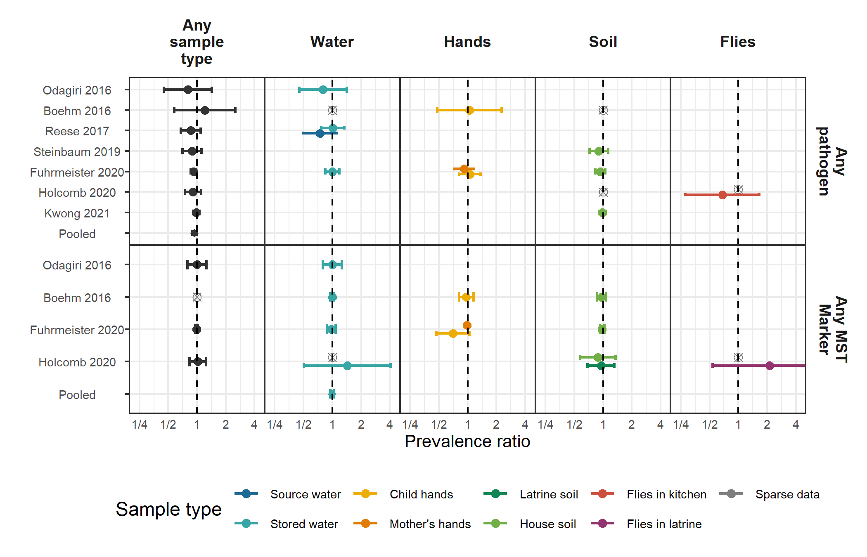

**Figure 1.** Forest plots of intervention effects on the prevalence of any enteropathogen, and any MST markers in different types of environmental samples. Pooled estimates are presented when there are four or more study-specific estimates for a specific sample type and target combination and are denoted with diamond-shaped points. Grey crossed points denote data that were too sparse to estimate a prevalence ratio (i.e., <10 positive or negative observations). Samples of the same type from different locations (source vs. stored water, flies in kitchen vs. latrine, soil from courtyard vs. latrine) or different individuals (child vs. mother’s hands) are plotted separately. All estimates are adjusted for potential confounders.

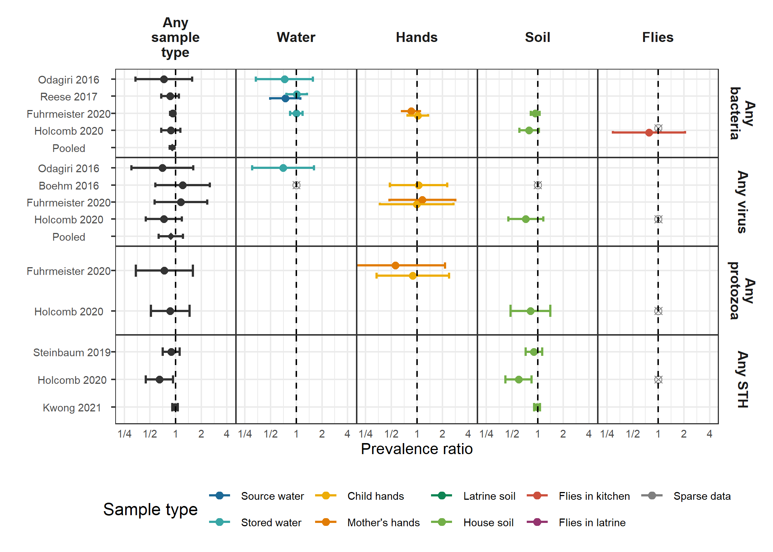

**Figure 2.** Forest plots of intervention effects on the prevalence of any virus, any bacteria, any protozoa and any STH in different types of environmental samples. Pooled estimates are presented when there are four or more study-specific estimates for a specific sample type and target combination and are denoted with diamond-shaped points. Grey crossed points denote data that were too sparse to estimate a prevalence ratio (i.e., <10 positive or negative observations). Samples of the same type from different locations (source vs. stored water, flies in kitchen vs. latrine, soil from courtyard vs. latrine) or different individuals (child vs. mother’s hands) are plotted separately. All estimates are adjusted for potential confounders.

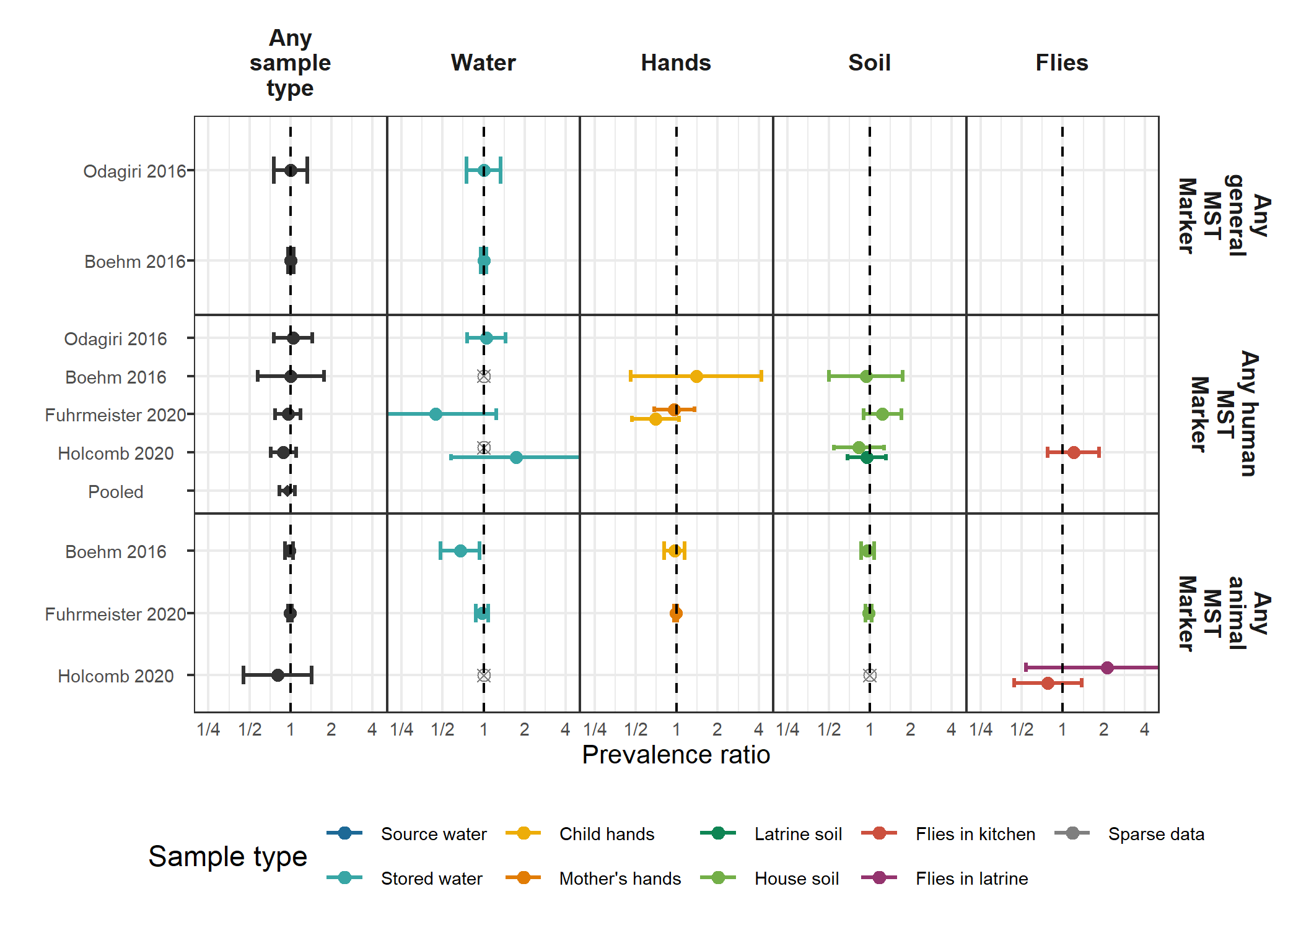

**Figure 3.** Forest plots of intervention effects on the prevalence of any general, human and animal MST markers in different types of environmental samples. Pooled estimates are presented when there are four or more study-specific estimates for a specific sample type and target combination and are denoted with diamond-shaped points. Grey crossed points denote data that were too sparse to estimate a prevalence ratio (i.e., <10 positive or negative observations). Samples of the same type from different locations (source vs. stored water, flies in kitchen vs. latrine, soil from courtyard vs. latrine) or different individuals (child vs. mother’s hands) are plotted separately. All estimates are adjusted for potential confounders.

## Tables

### Table 1. Characteristics of included publications

| **Parent study** | **Study design** | **Intervention** | **Location** | **Author/ year** | **Sample types** | **Targets** | **Analytic method** | **Number of samples** |
| --- | --- | --- | --- | --- | --- | --- | --- | --- |
| WASH Benefits Bangladesh | Cluster-randomized trial | Latrine upgrades, child potties, scoops for feces disposal | Rural Bangladesh | Boehm et al. 2016 | Stored drinking water, child hands, soil | Rotavirus, General, human, avian and ruminant fecal markers | qPCR | 1,497 |
| - | - | - | - | Fuhrmeister et al. 2020 | Stored drinking water, child and mother hands, soil | Pathogenic E. coli, norovirus, Giardia | qPCR | 2,606 |
| - | - | - | - | Kwong et al. 2021 | Courtyard soil | Soil-transmitted helminths | Microscopy | 1,396 |
| WASH Benefits Kenya | Cluster-randomized trial | Latrine upgrades, child potties, scoops for feces disposal | Rural Kenya | Steinbaum et al. 2019 | Courtyard soil | Soil-transmitted helminths | Microscopy | 2,107 |
| MapSan | Controlled before-and-after study | Latrine upgrades | Urban Mozambique | Holcomb et al. 2020 | Source and stored water, household and latrine soil, food, flies caught in latrine and kitchen | Panel of 17 enteropathogens, human and avian fecal markers | qPCR | 1,081 |
| Gram Vikas | Matched cohort study | Latrine upgrades, piped water | Rural India | Reese et al. 2017 | Source and stored water | V. cholerae, Shigella | Slide agglutination serotyping | 3,452 |
| Total Sanitation Campaign | Cluster-randomized trial | Latrine upgrades | Rural India | Odagiri et al. 2016 | Source water | V. cholerae, rotavirus, adenovirus,general, human, and animal fecal markers | qPCR, microscopy | 60 |

### 

### Table 2. Mean (SD) abundances by study arm arm and adjusted abundance differences between intervention and control arms. Means are log10 transformed concentrations for MST markers, and are mean egg counts for soil transmitted helminths (*Ascaris* and *Trichuris*).

| **Study** | **Sample** | **Target** | **N** | **ROQ %** | **Control mean (SD)** | **Intervention mean (SD)** | **Difference (95% CI)** | **P value** |
| --- | --- | --- | --- | --- | --- | --- | --- | --- |
| Boehm 2016 | Stored water | General (GenBac3) | 479 | 83.9 | 1.8 (1.1) | 1.7 (1) | -0.09 (-0.29 0.1) | 0.35 |
| - | Child hands | General (GenBac3) | 493 | 98.0 | 5.5 (0.9) | 5.5 (1.1) | 0.04 (-0.17 0.25) | 0.74 |
| - | House soil | General (GenBac3) | 483 | 100.0 | 6.6 (0.9) | 6.4 (0.9) | -0.2 (-0.37 -0.02) | 0.03 |
| Fuhrmeister 2020 | Child hands | Cow (BacCow) | 365 | 75.9 | 3.6 (1.4) | 3.4 (1.4) | -0.17 (-0.47 0.12) | 0.25 |
| - | Mother's hands | Cow (BacCow) | 725 | 66.5 | 3.3 (1.4) | 3 (1.5) | -0.28 (-0.49 -0.07) | 0.01 |
| Holcomb 2020 | Latrine soil | Human (M. smithii) | 113 | 51.3 | 6.7 (0.6) | 6.5 (0.5) | -0.13 (-0.34 0.07) | 0.19 |
| - | Flies in kitchen | Human (Bacteroides) | 113 | 77.0 | 3.8 (1.2) | 3.9 (0.9) | 0.23 (-0.16 0.62) | 0.26 |
| - | Flies in latrine | Human (Bacteroides) | 60 | 78.3 | 3.9 (1.3) | 4.6 (0.7) | 0.7 (0.11 1.28) | 0.02 |
| Steinbaum 2019 | House soil | Ascaris | 2,101 | 100.0 | 2.2 (18.8) | 1.4 (9.3) | 0.65 (0.33 1.28)a | 0.21 |
| - | - | Trichuris | 2,102 | 100.0 | 0.2 (1.8) | 0.2 (1) | 0.73 (0.36 1.48)a | 0.38 |
| Kwong 2021 | House soil | Ascaris | 1,423 | 100.0 | 2.3 (6.7) | 2.2 (6.9) | 0.96 (0.68 1.37)a | 0.84 |
| - | - | Trichuris | 1,423 | 100.0 | 1.6 (5) | 2 (5) | 1.21 (0.86 1.71)a | 0.27 |

ROQ: Range of quantification; SD: Standard deviation; CI: Confidence interval.

a Marks estimates from negative binomial models.

## Supplementary Figures

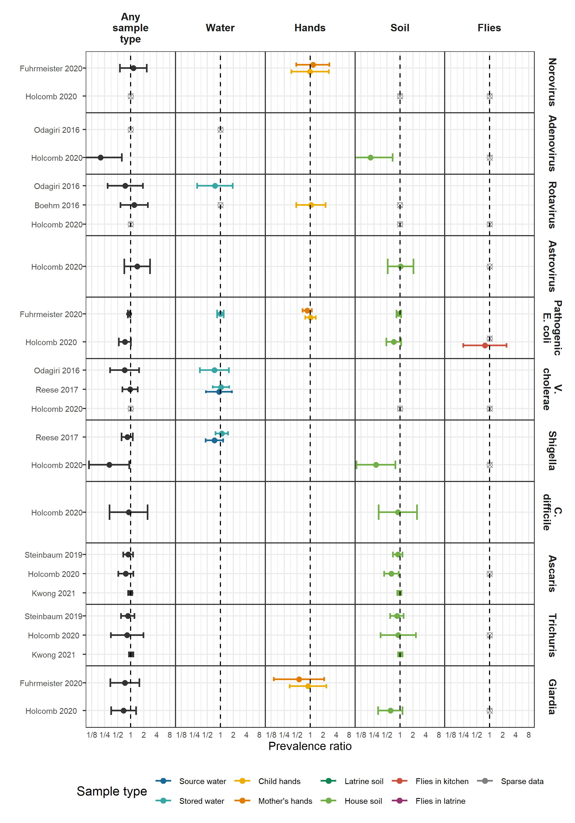

**Figure S1.** Forest plots of intervention effects on the prevalence of specific pathogens.

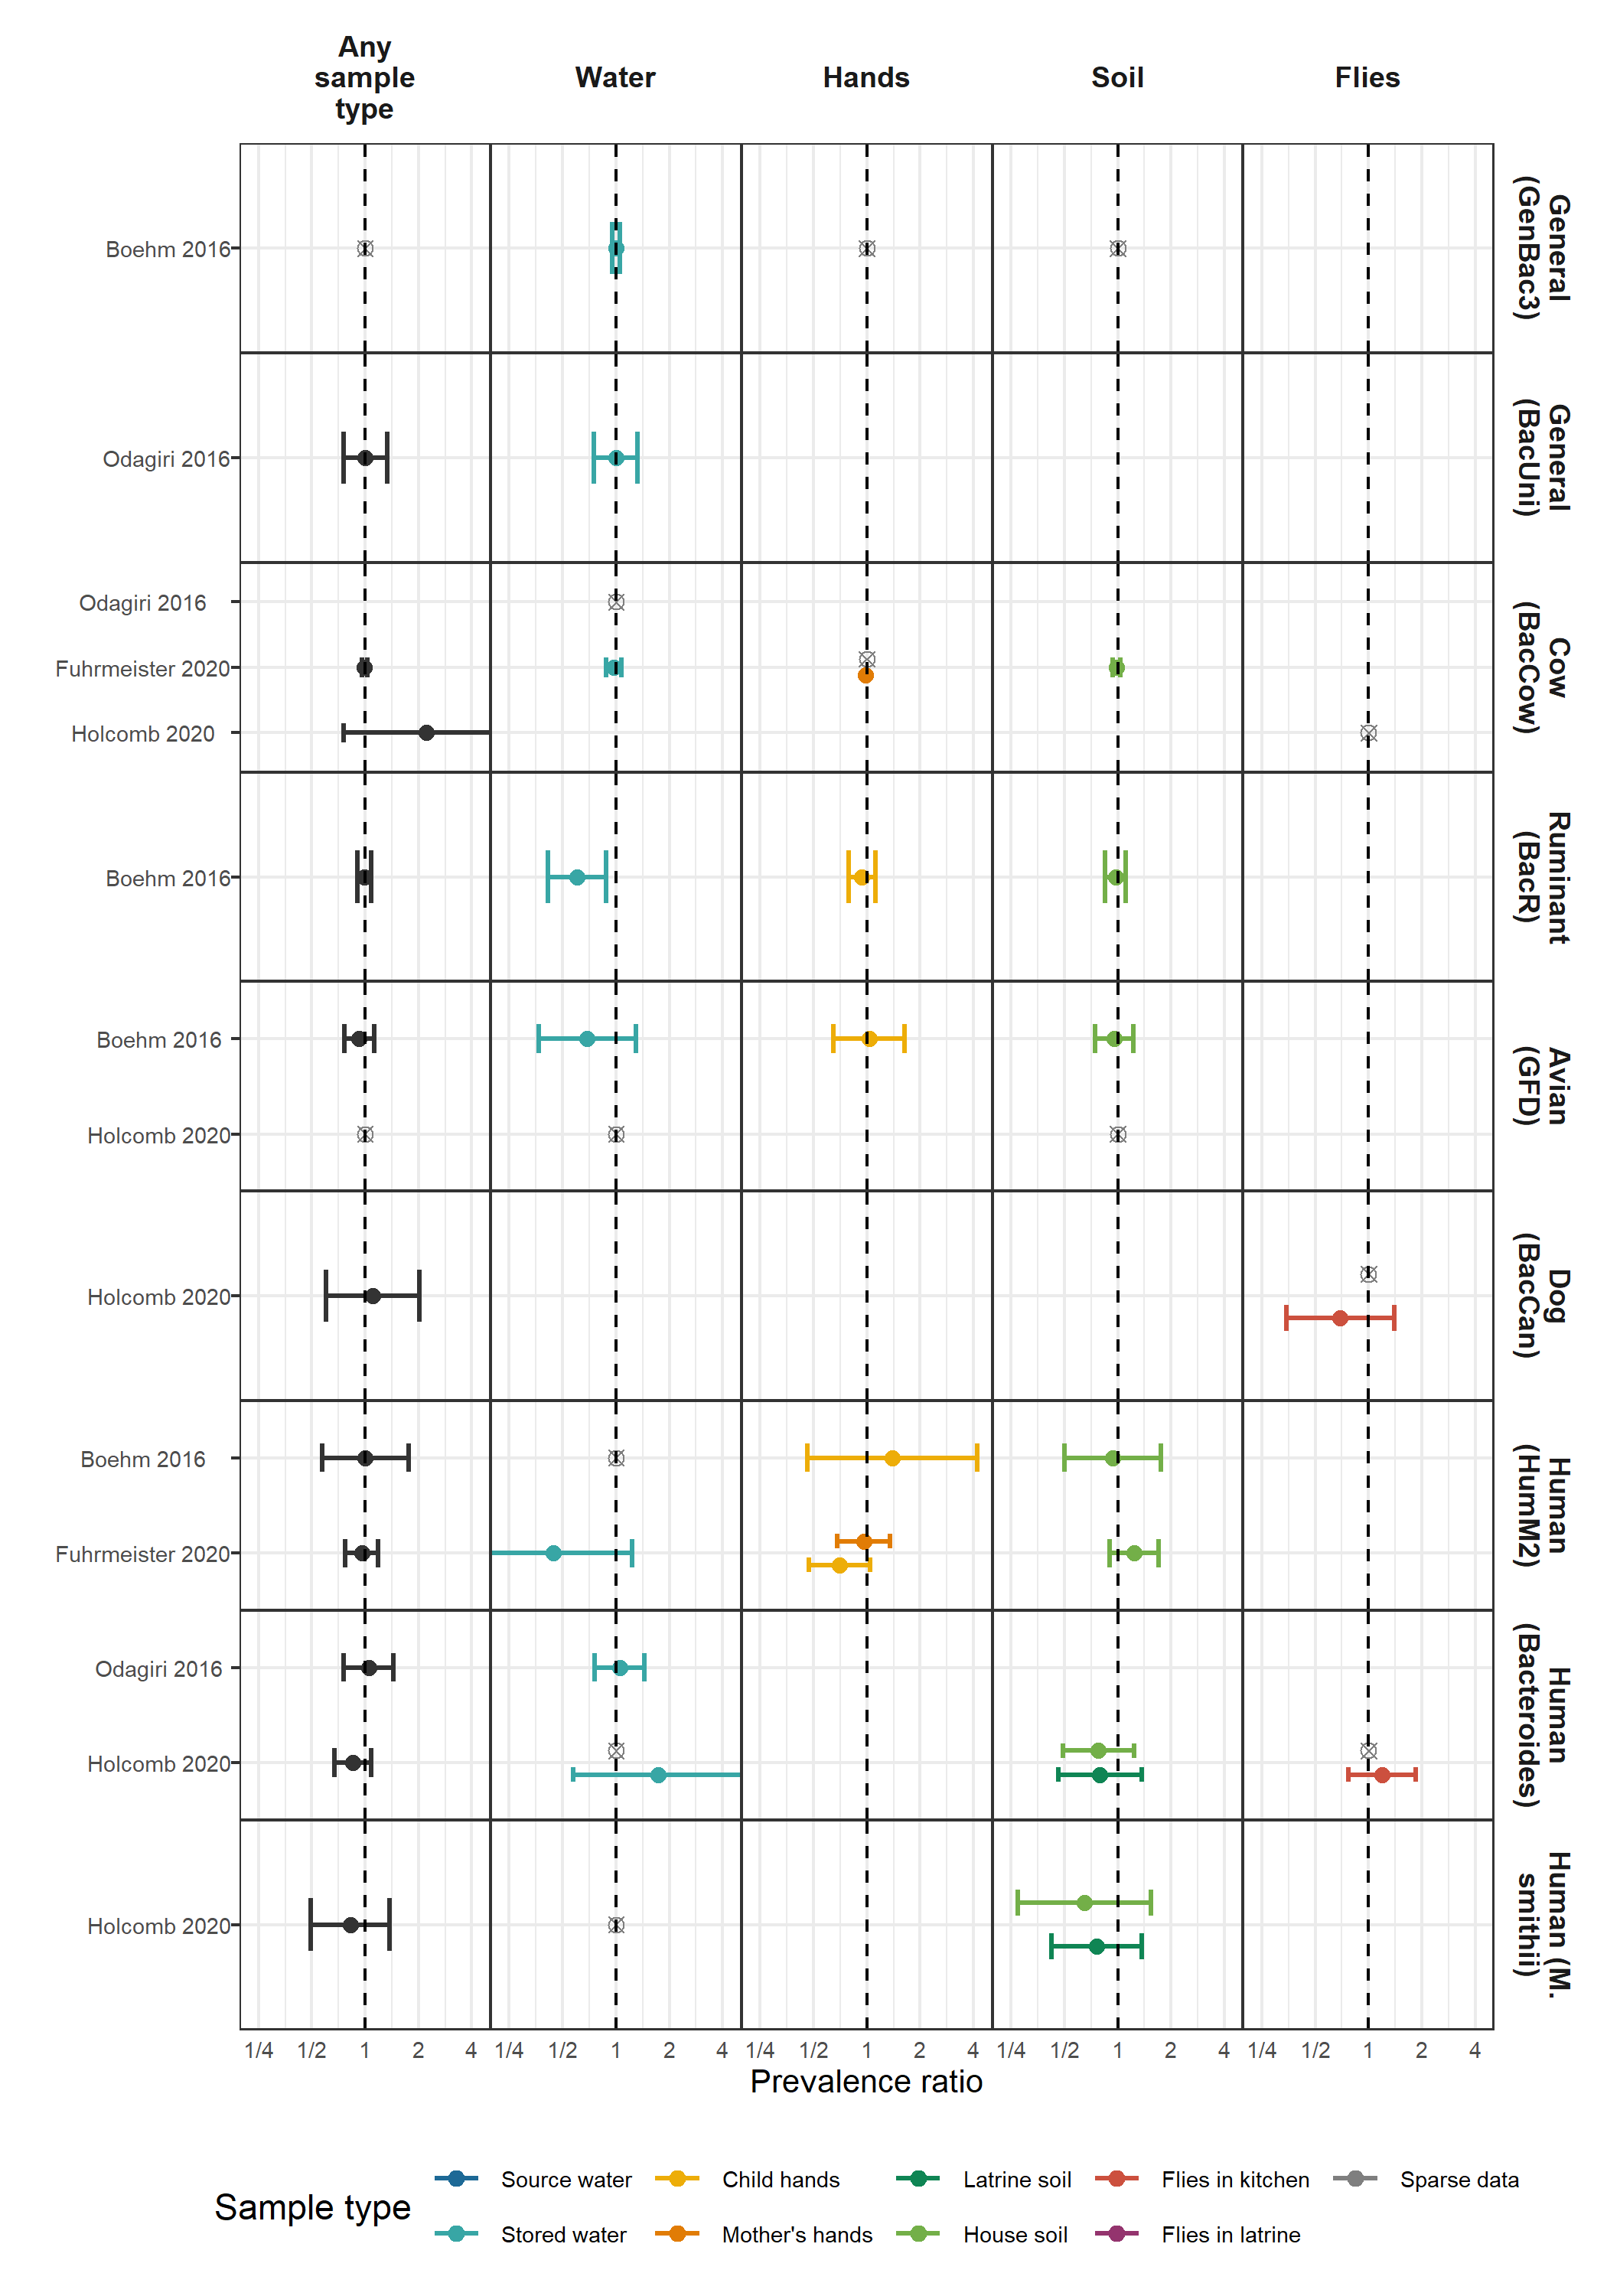

**Figure S2.** Forest plots of intervention effects on the prevalence of specific MST markers.

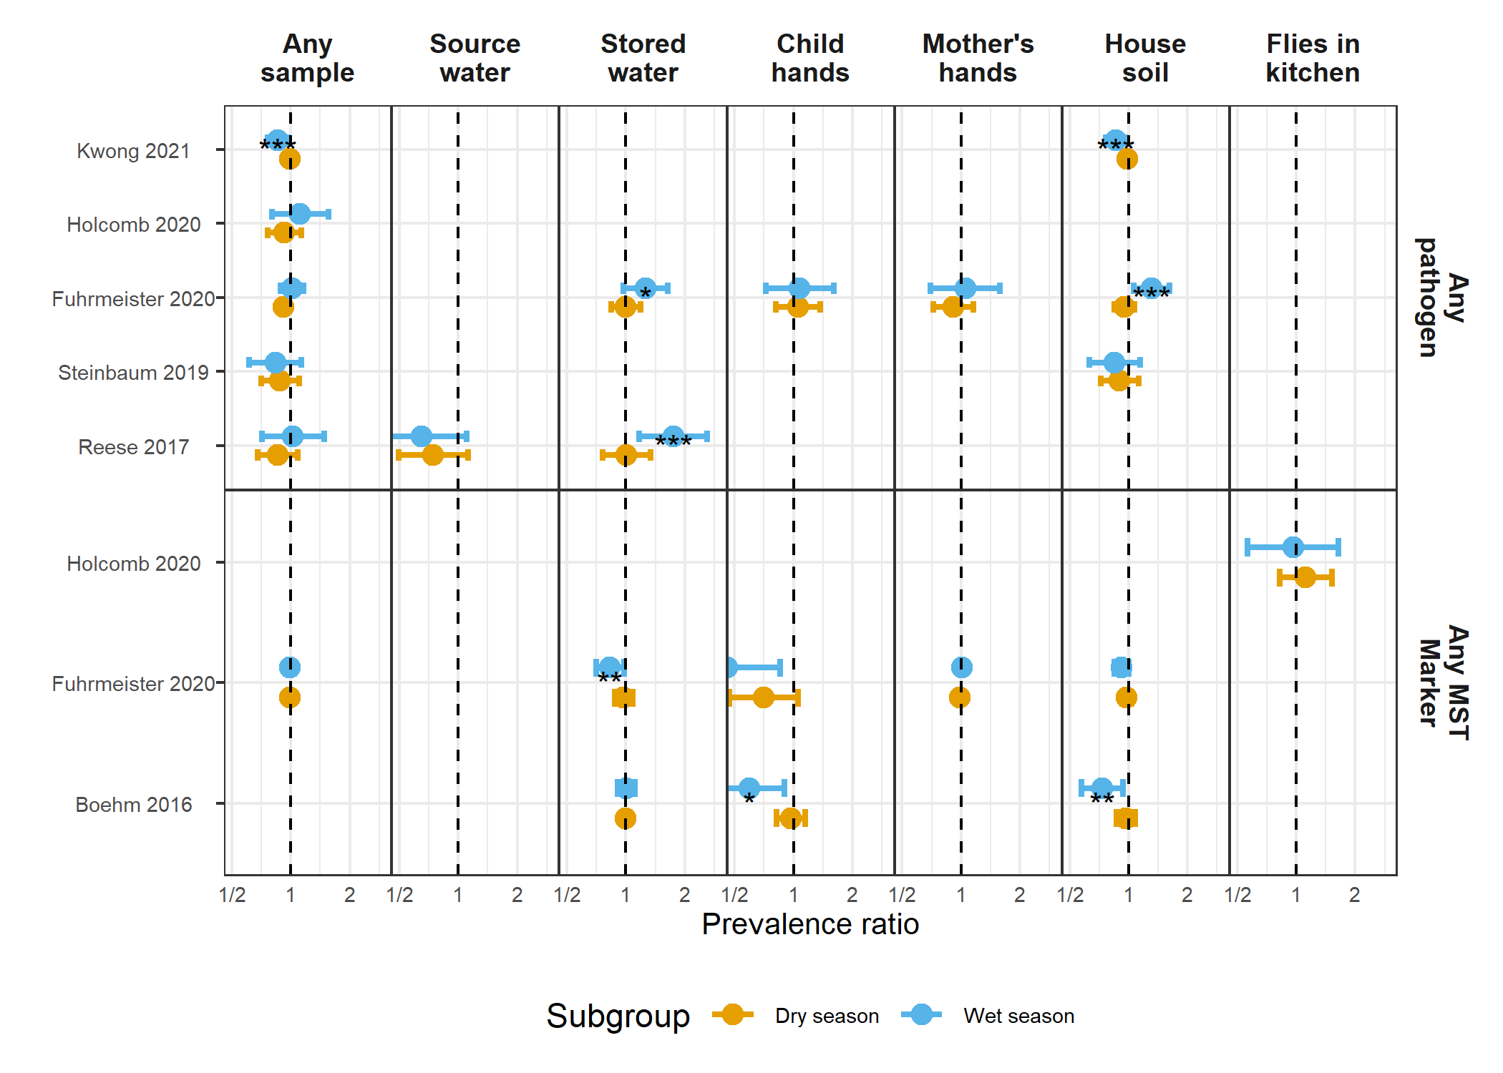

**Figure S3.** Forest plots of intervention effects on any enteropathogen, and any MST markers in different types of environmental samples, stratified by whether the sample was collected during the wet versus dry season (defined by the 6 months of highest average rainfall). Significant effect modification, as determined by the p-values on the regression model interaction term, is marked with asterisks (P < 0.05 = “*”, P < 0.01 = “**”, P < 0.001 = “***”).

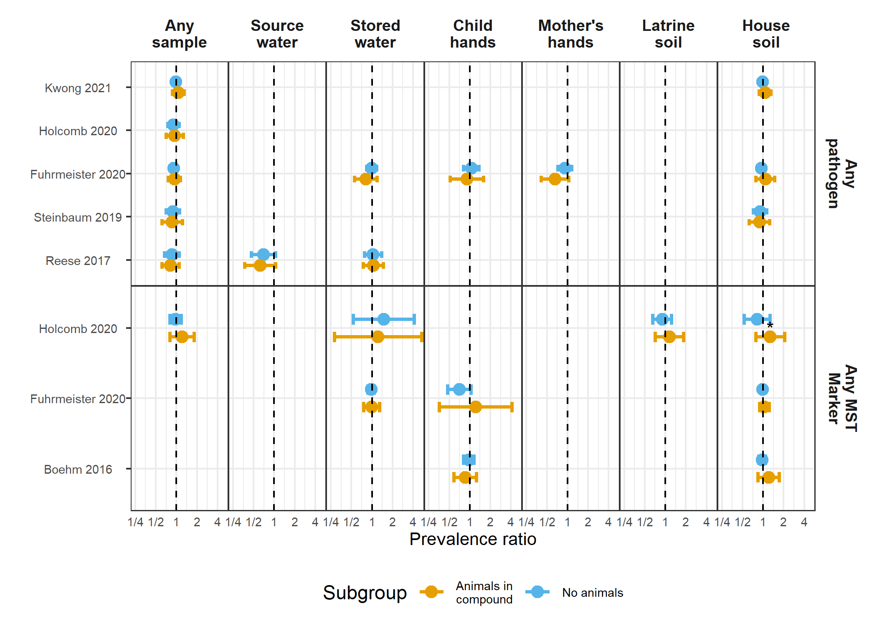

**Figure S4.** Forest plots of intervention effects on any enteropathogen, and any MST markers in different types of environmental samples, stratified by whether any animals were present in the compound. Significant effect modification, as determined by the p-values on the regression model interaction term, is marked with asterisks (P < 0.05 = “*”, P < 0.01 = “**”, P < 0.001 = “***”).

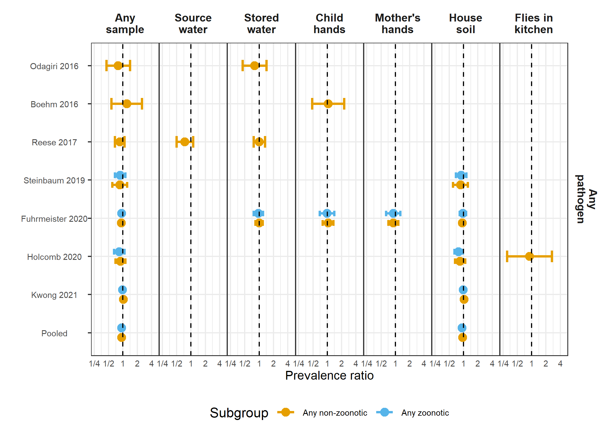

**Figure S5.** Forest plots of intervention effects on any enteropathogen in any type of environmental samples , stratified by whether the pathogen is zoonotically transmitted.

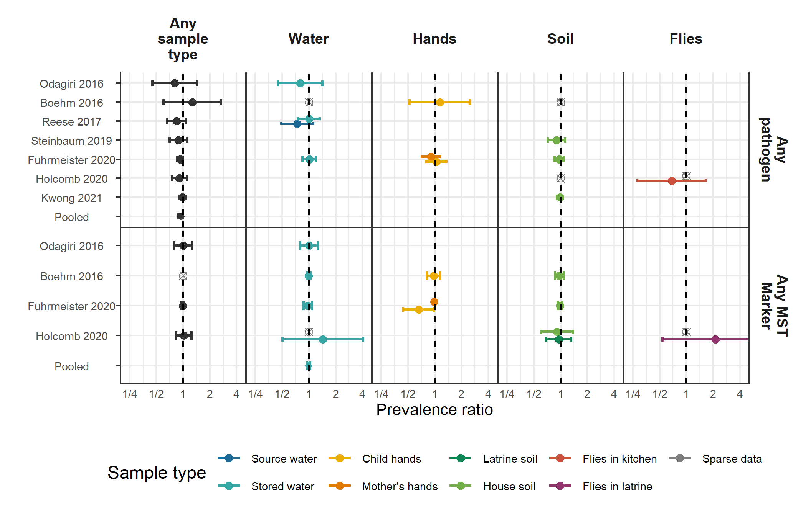

**Figure S6.** Forest plots of unadjusted intervention effects on the prevalence of any enteropathogen, and any MST markers in different types of environmental samples.

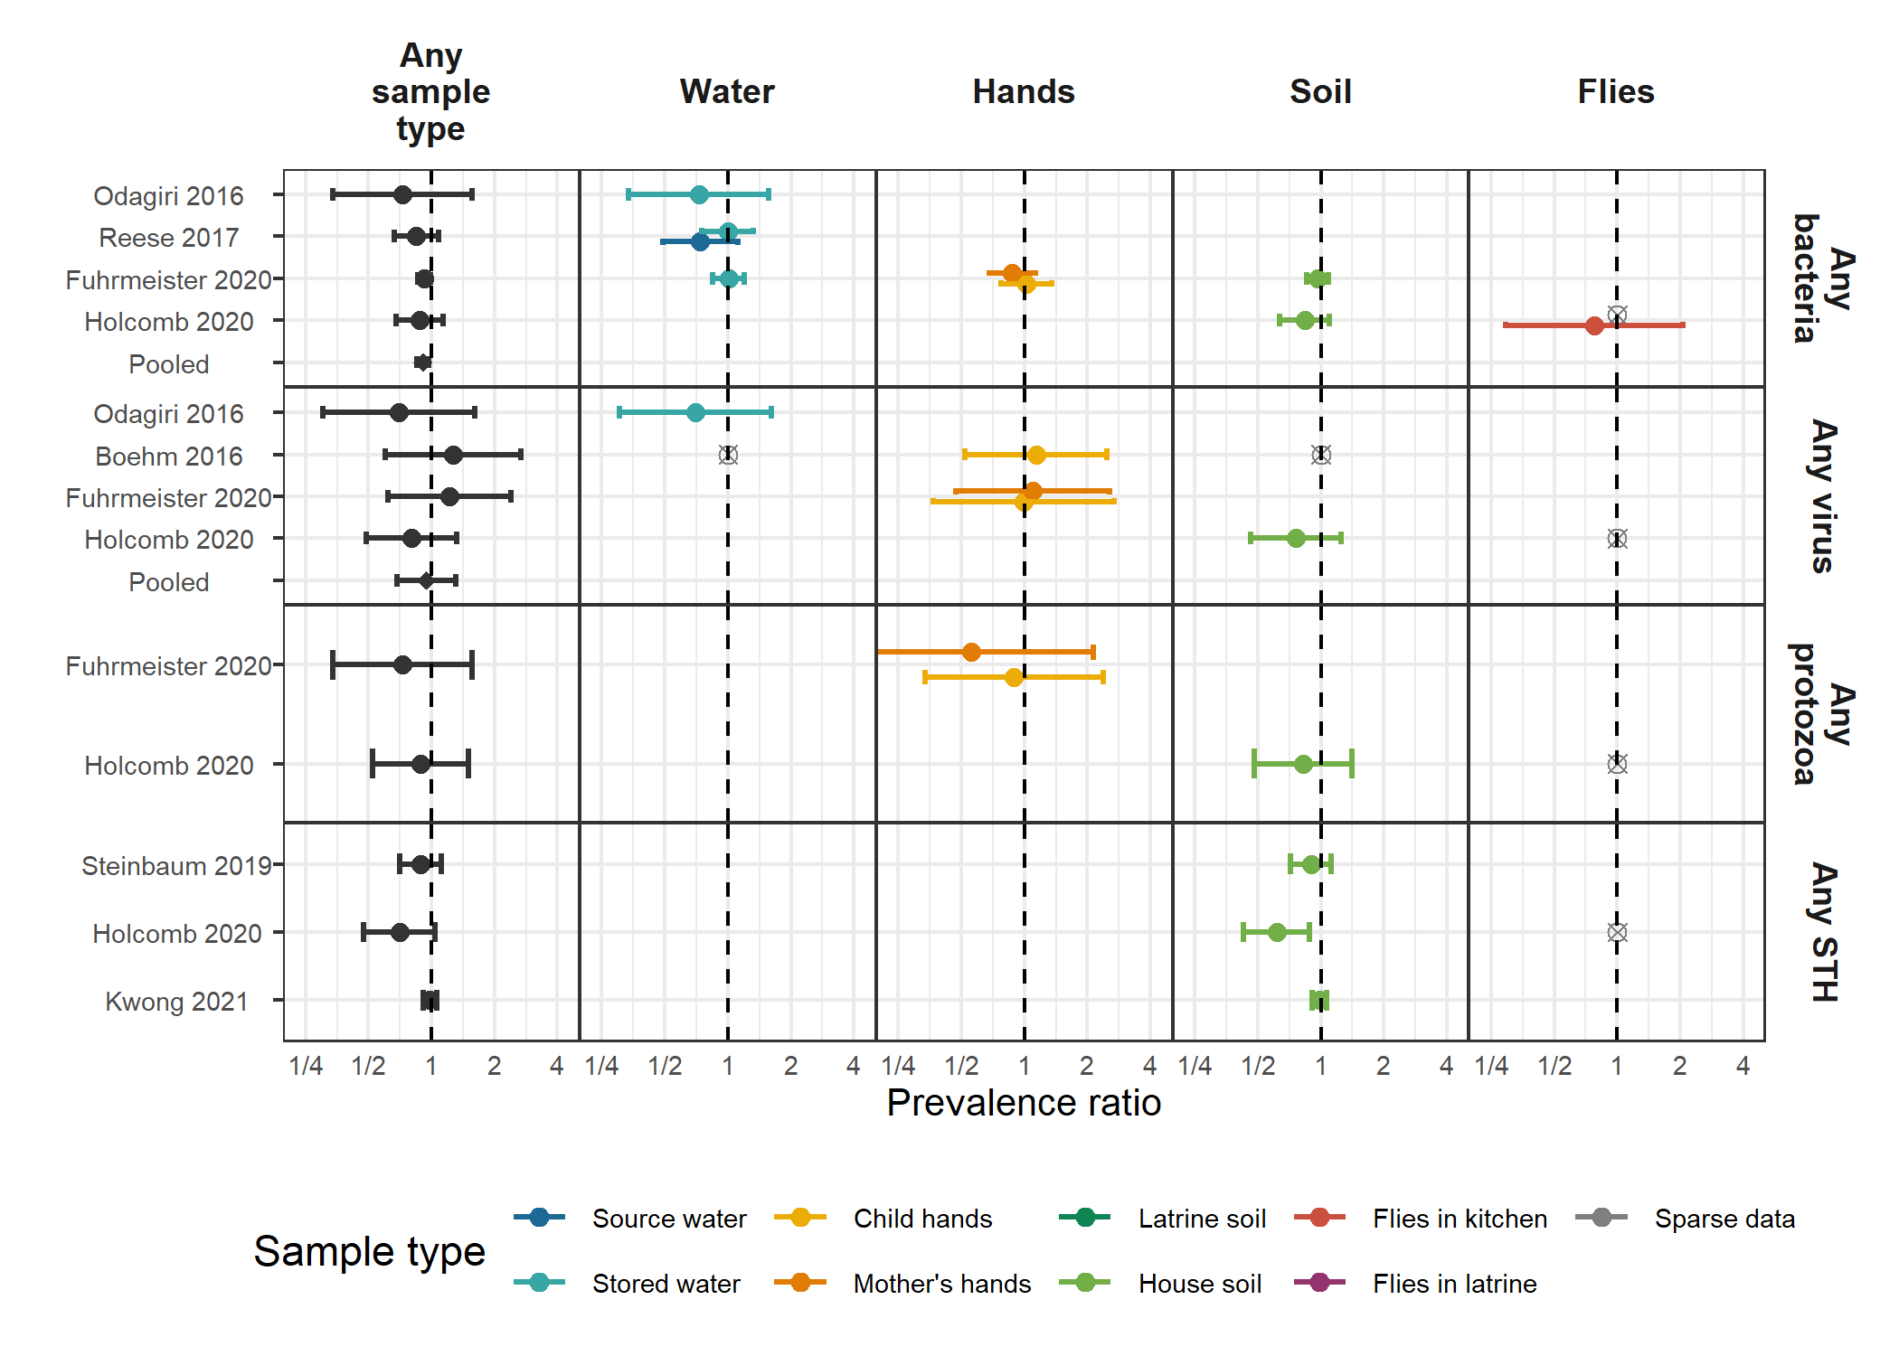

**Figure S7.** Forest plots of unadjusted intervention effects on the prevalence of any virus, any bacteria, any protozoa and any STH in different types of environmental samples.

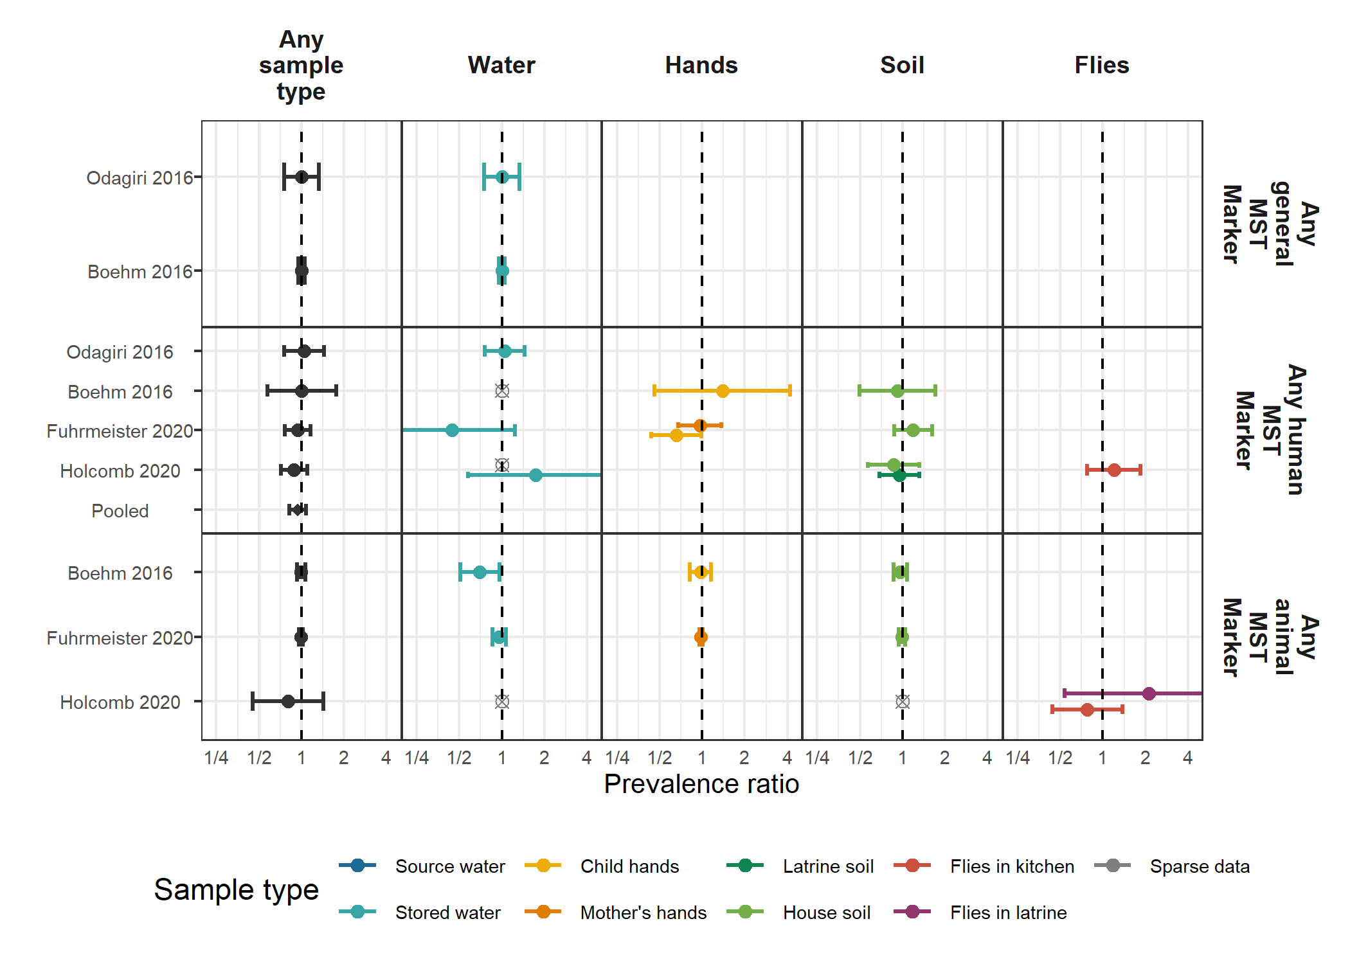

**Figure S8.** Forest plots of unadjusted intervention effects on the prevalence of any general, human and animal MST markers in different types of environmental samples.

## 

## References

1. Humphrey, J. H. *et al.* Independent and combined effects of improved water, sanitation, and hygiene, and improved complementary feeding, on child stunting and anaemia in rural Zimbabwe: A cluster-randomised trial. *The Lancet. Global Health* **7**, e132–e147 (2019).

2. Luby, S. P. *et al.* Effects of water quality, sanitation, handwashing, and nutritional interventions on diarrhoea and child growth in rural Bangladesh: A cluster randomised controlled trial. *The Lancet Global Health* **6**, e302–e315 (2018).

3. Null, C. *et al.* Effects of water quality, sanitation, handwashing, and nutritional interventions on diarrhoea and child growth in rural Kenya: A cluster-randomised controlled trial. *The Lancet. Global Health* **6**, e316–e329 (2018).

4. Sclar, G. D. *et al.* Assessing the impact of sanitation on indicators of fecal exposure along principal transmission pathways: A systematic review. *International Journal of Hygiene and Environmental Health* **219**, 709–723 (2016).

5. Arnold, B. F. & Colford, J. M. Treating water with chlorine at point-of-use to improve water quality and reduce child diarrhea in developing countries: A systematic review and meta-analysis. *The American journal of tropical medicine and hygiene* **76**, 354–364 (2007).

6. Luby, S. P. *et al.* Microbiologic effectiveness of hand washing with soap in an urban squatter settlement, Karachi, Pakistan. *Epidemiology and Infection* **127**, 237–244 (2001).

7. Pickering, A. J., Boehm, A. B., Mwanjali, M. & Davis, J. Efficacy of waterless hand hygiene compared with handwashing with soap: A field study in Dar es Salaam, Tanzania. *The American Journal of Tropical Medicine and Hygiene* **82**, 270–278 (2010).

8. Hardina, C. M. & Fujioka, R. S. Soil: The environmental source of Escherichia coli and enterococci in Hawaii’s streams. *Environmental Toxicology and Water Quality* **6**, 185–195 (1991).

9. Gruber, J. S., Ercumen, A. & Colford, J. M. Coliform bacteria as indicators of diarrheal risk in household drinking water: Systematic review and meta-analysis. *PloS One* **9**, e107429 (2014).

10. Wu, J., Long, S. C., Das, D. & Dorner, S. M. Are microbial indicators and pathogens correlated? A statistical analysis of 40 years of research. *Journal of Water and Health* **9**, 265–278 (2011).

11. Lappan, R. *et al.* Monitoring of diverse enteric pathogens across environmental and host reservoirs with TaqMan array cards and standard qPCR: A methodological comparison study. *The Lancet. Planetary Health* **5**, e297–e308 (2021).

12. Liu, J. *et al.* A laboratory-developed TaqMan Array Card for simultaneous detection of 19 enteropathogens. *Journal of Clinical Microbiology* **51**, 472–480 (2013).

13. Stoeckel, D. M. & Harwood, V. J. Performance, Design, and Analysis in Microbial Source Tracking Studies. *Applied and Environmental Microbiology* **73**, 2405–2415 (2007).

14. Motlagh, A. M. & Yang, Z. Detection and occurrence of indicator organisms and pathogens. *Water Environment Research* **91**, 1402–1408 (2019).

15. Zou, G. A modified poisson regression approach to prospective studies with binary data. *American Journal of Epidemiology* **159**, 702–706 (2004).

16. Freedman, D. A. On The So-Called ‘Huber Sandwich Estimator’ and ‘Robust Standard Errors’. *The American Statistician* **60**, 299–302 (2006).

17. Cochran, W. G. The Combination of Estimates from Different Experiments. *Biometrics* **10**, 101–129 (1954).

18. Cochran, W. G. The Combination of Estimates from Different Experiments. *Biometrics* **10**, 101–129 (1954).

19. d.o.o, Y. M. G. Weather Atlas | Weather forecast and Climate information for cities all over the Globe. *Weather Atlas*.

20. Delahoy, M. J. *et al.* Pathogens transmitted in animal feces in low- and middle-income countries. *International Journal of Hygiene and Environmental Health* **221**, 661–676 (2018).

21. Arnold, B. F. *et al.* Cluster-randomised controlled trials of individual and combined water, sanitation, hygiene and nutritional interventions in rural Bangladesh and Kenya: The WASH Benefits study design and rationale. *BMJ Open* **3**, e003476 (2013).

22. Brown, J. *et al.* A controlled, before-and-after trial of an urban sanitation intervention to reduce enteric infections in children: Research protocol for the Maputo Sanitation (MapSan) study, Mozambique. *BMJ Open* **5**, e008215 (2015).

23. Reese, H. *et al.* Design and rationale of a matched cohort study to assess the effectiveness of a combined household-level piped water and sanitation intervention in rural Odisha, India. *BMJ open* **7**, e012719 (2017).

24. Clasen, T. *et al.* Effectiveness of a rural sanitation programme on diarrhoea, soil-transmitted helminth infection, and child malnutrition in Odisha, India: A cluster-randomised trial. *The Lancet. Global Health* **2**, e645–653 (2014).

25. George, C. M. *et al.* Randomized Controlled Trial of Hospital-Based Hygiene and Water Treatment Intervention (CHoBI7) to Reduce Cholera. *Emerging Infectious Diseases* **22**, 233–241 (2016).

26. Kwong, L. H. *et al.* Effect of sanitation improvements on soil-transmitted helminth eggs in courtyard soil from rural Bangladesh: Evidence from a cluster-randomized controlled trial. *bioRxiv* 2020.09.29.318097 (2020) doi:[10.1101/2020.09.29.318097](https://doi.org/10.1101/2020.09.29.318097).

27. Steinbaum, L. *et al.* Effect of a sanitation intervention on soil-transmitted helminth prevalence and concentration in household soil: A cluster-randomized controlled trial and risk factor analysis. *PLoS neglected tropical diseases* **13**, e0007180 (2019).

28. Reese, H. Effectiveness of a combined sanitation and household-level piped water intervention on infrastructure coverage, availability and use, environmental fecal contamination, and child health in rural Odisha, India: A matched cohort study. (Emory University, 2017).

29. Boehm, A. B. *et al.* Occurrence of Host-Associated Fecal Markers on Child Hands, Household Soil, and Drinking Water in Rural Bangladeshi Households. *Environmental Science & Technology Letters* **3**, 393–398 (2016).

30. Fuhrmeister, E. R. *et al.* Effect of Sanitation Improvements on Pathogens and Microbial Source Tracking Markers in the Rural Bangladeshi Household Environment. *Environmental Science & Technology* **54**, 4316–4326 (2020).

31. Odagiri, M. *et al.* Human fecal and pathogen exposure pathways in rural Indian villages and the effect of increased latrine coverage. *Water Research* **100**, 232–244 (2016).

32. Holcomb, D. A. *et al.* Human fecal contamination of water, soil, and surfaces in households sharing poor-quality sanitation facilities in Maputo, Mozambique. *International Journal of Hygiene and Environmental Health* **226**, 113496 (2020).

33. Riley, R. D., Lambert, P. C. & Abo-Zaid, G. Meta-analysis of individual participant data: Rationale, conduct, and reporting. *BMJ* **340**, c221 (2010).

34. Ercumen, A. *et al.* Animal Feces Contribute to Domestic Fecal Contamination: Evidence from E. Coli Measured in Water, Hands, Food, Flies, and Soil in Bangladesh. *Environmental Science & Technology* **51**, 8725–8734 (2017).

35. Pickering, A. J. *et al.* The WASH Benefits and SHINE trials: Interpretation of WASH intervention effects on linear growth and diarrhoea. *The Lancet Global Health* **7**, e1139–e1146 (2019).